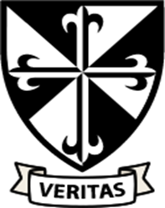

**RE**

In RE, we will be learning about beginnings. We will think about how God is present at every beginning and that He was there at the beginning of the world.

The children will then learn about Judaism, thinking especially about the special day of Shabbat.

We will then move on to learning all about promises made at Baptism. Children learn about the signs and symbols used in Baptism.

**Year 2**

**Autumn Term 1**

**Computing**

In Computing, we will practice safe and appropriate online behaviour. We will also think about different computer systems.

**Art**

In Art we will be learning all about surrealist landscapes and studying the work of Salvador Dali and Frida Kahlo. We will look at individual aspects of the art before designing and creating our own pieces.

**English**

This half term we will be reading some traditional tales and comparing them with traditional tales with a twist. Our class text will be Little Red Reading Hood. The children will rewrite the story changing the main character. We will focus on using complex sentences, repetition and personification. Our non-fiction text will be I am Neil Armstrong. The children will write interview questions and answers related to a famous figure. We will develop our phonic skills using the RWI scheme and use VIPERS to support our guided reading and reading comprehension skills.

We will follow the RWI scheme for. Phonics. In reading we will develop fluency, retrieval and inferencing skills.

**Music**

In Music, we will be listening to and appraising South African music. We will also be listening to some rap music and improvising our own rap.

.

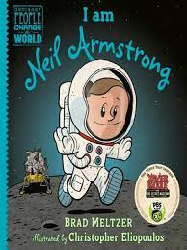

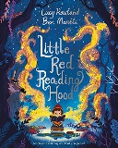

**PSHE**

In PSHE, we will learn about how we are all Created and Loved by God. We will celebrate similarities and differences between people, including our God-given bodies and the things they enable us to do! Teaching also includes maintaining personal hygiene and the physical differences between boys and girls.

**Maths**

We will investigate numbers 10 to 100, which includes composing multiples of 10. Representing multiples of ten using numerals and other ways of recoding. Placing multiples of 10 on a number line. Fluently adding and subtracting within 10 then move on to calculations within 20.

Calculations within 20

**History**

In History we are learning all about explorers. We will be thinking about how we can find out about the past and why people explore. We will be looking at some famous explorers such as Christopher Columbus, Neil Armstrong and Gertrude Bell.

**PE**

In PE, we will be developing our skills in invasion, learning football skills in particular with NUFC. We will also be doing some multi-skills – throwing and catching, before learning hockey skills.

**Science**

In Science we will learn about the basic needs that all humans need to survive and live. We will learn about the importance of exercise, a healthy diet and good hygiene as ways to keep us healthy.